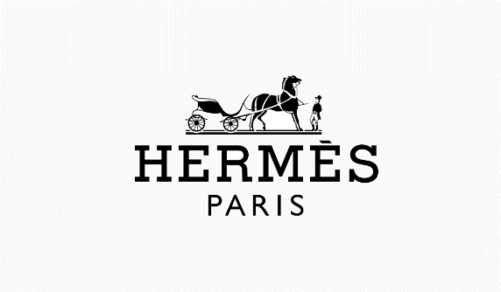

##### UN JARDIN EN MEDITERRENEE

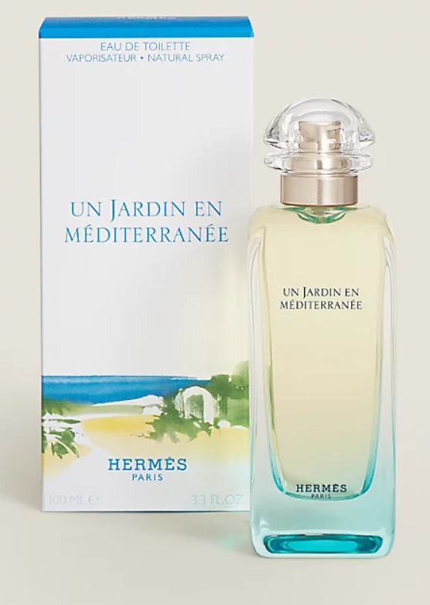

**Un Jardin en Méditerranée** by **Hermès** is a Floral Aquatic fragrance for women and men. **Un Jardin en Méditerranée** was launched in 2003. The nose behind this fragrance is Jean-Claude Ellena. Top notes are Bergamot, Lemon and Mandarin Orange; middle notes are Orange Blossom and White Nerium Oleander; base notes are Fig Leaf, Cypress, Red Cedar, Juniper, Pistachio and Musk.

Un Jardin en Méditerranée: conceived as a watercolour, this perfume, composed in 2003 is inspired by a hint of the poetic in the Tunisian garden of Leïla Menchari (Director of displays for Hermès). Like a travel journal, it evokes that paradise-like universe of shade,water and light, based on the theme of a fig tree in the morning and Mediterranean citrus.